6/2/2014

Advanced Internet & Web Services

Final Project installation guide

**Class:** 4C13

**Students:**

Trịnh Hải Long- 1301040124

Bùi Thị Diệu - 1301040031

Trần Thị Hồng Nhung – 1301040161

Bùi Thị Thu Hương

**Contents**

I. General 2

II. Server Config 2

III. Client Config 3

|  |
| --- |
| 1. **General** |

* Exact project file

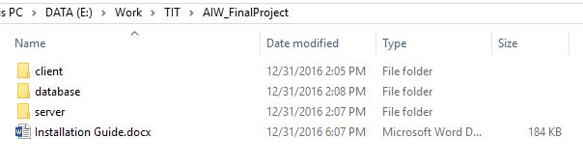

|  |
| --- |
| 1. **Server Config** |

* **create and import database**

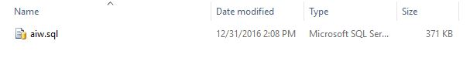

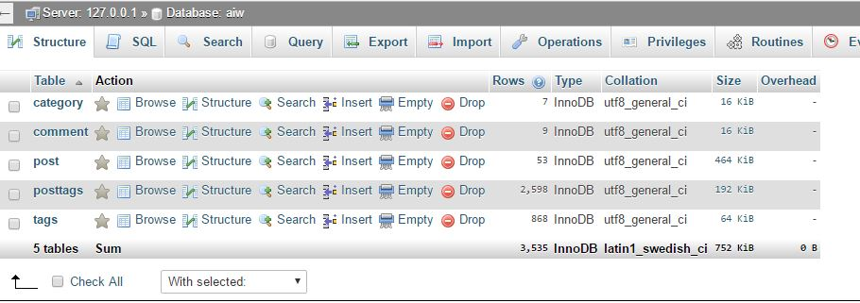

* **coppy file in server folder to your website that will run server**

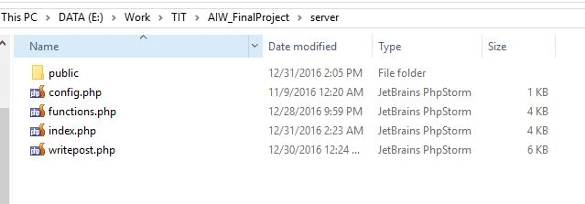

* **open config.php and edit with your server information**

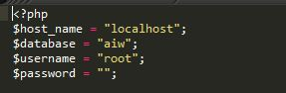

* **checkout**

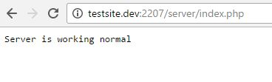

|  |
| --- |
| 1. **Client Config** |

* **coppy file in client folder to your website**

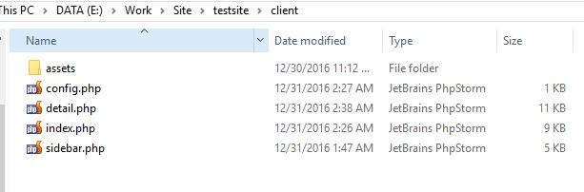

* **open config.php and edit link to your server (default value is online server ,can use it if dont want install server).**

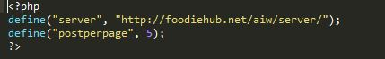

* **run your client and enjoy!**

